**ROLL NO: 1902026**

**NAME: DHANYA.G**

**BATCH ID: B10-4A6E**

CODE:

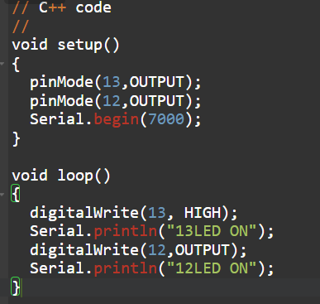

SIMULATION:

